* 寫入分析結果的路徑：eda\temp_folder\temp\
* 測試四種方法：FFT, CWT, DWT, EEMD 每種方法分GET, POST, DELETE
* FFT 測試

1. FFT POST:

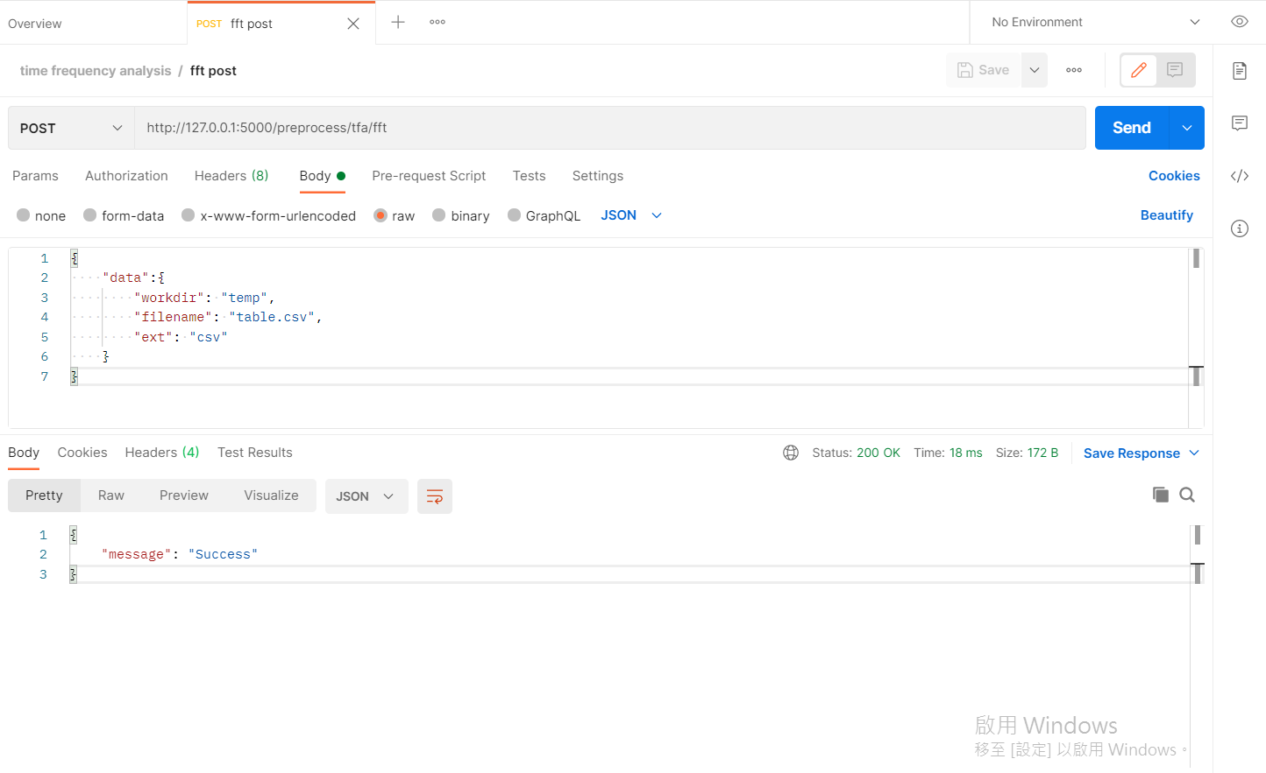

1. FFT GET:

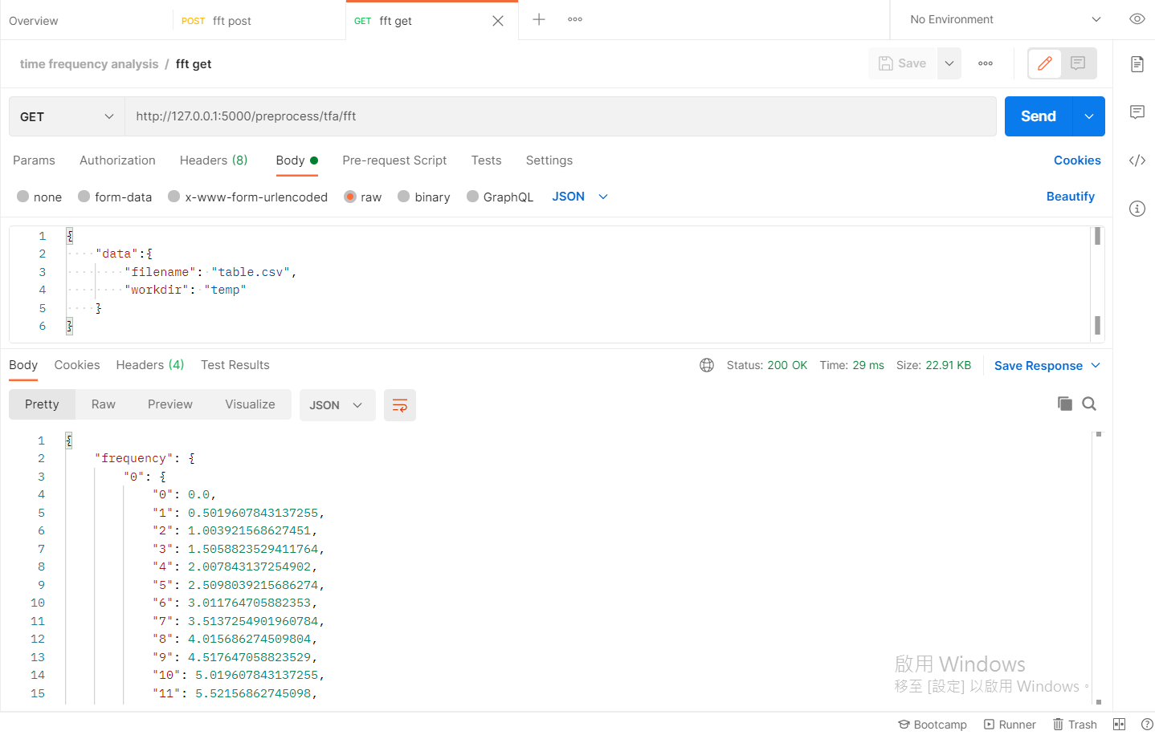

1. FFT DELETE:

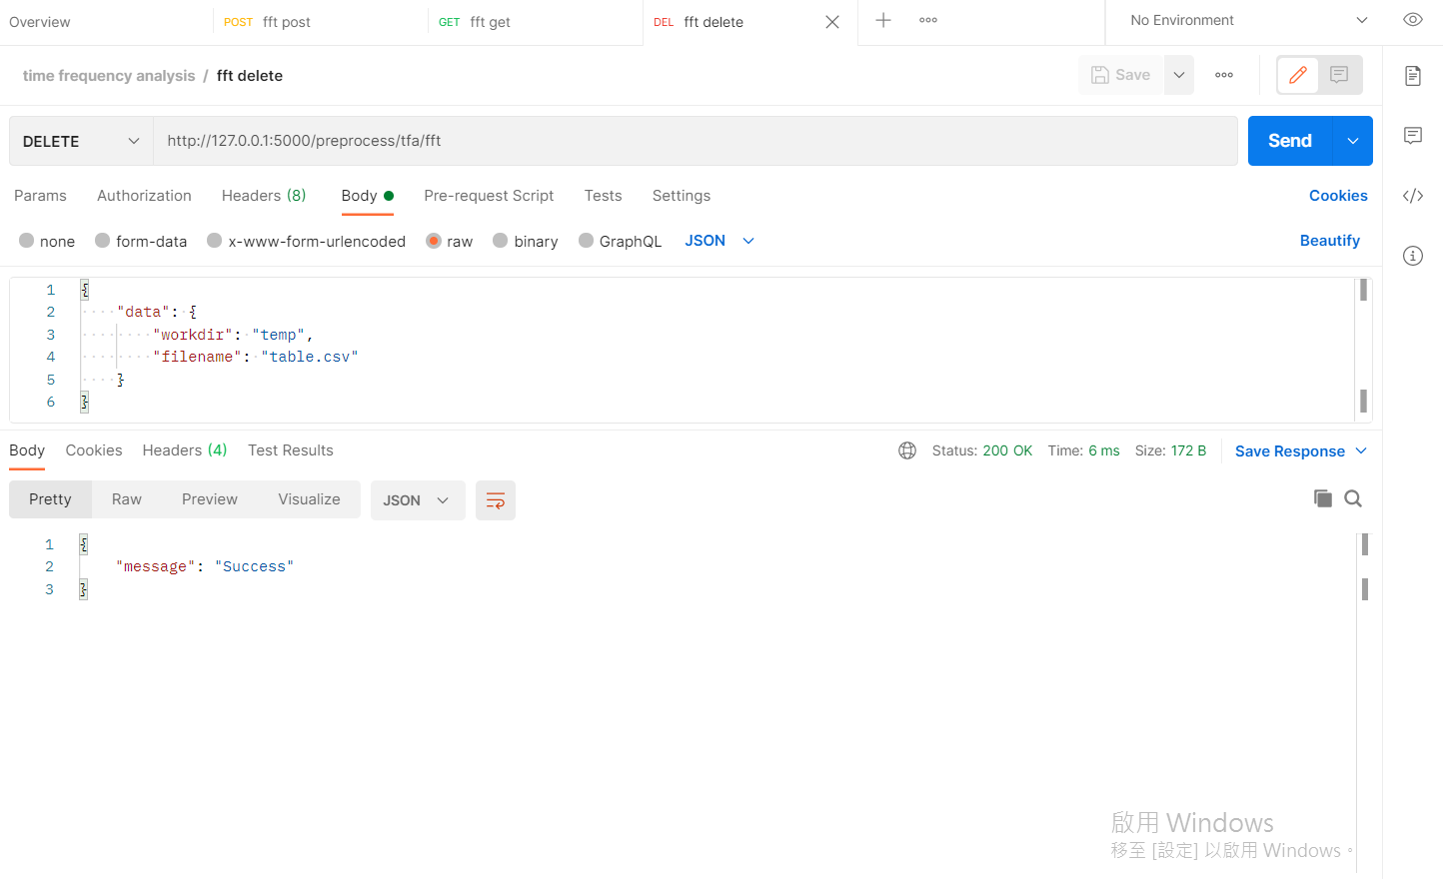

* DWT 測試:

1. DWT POST:

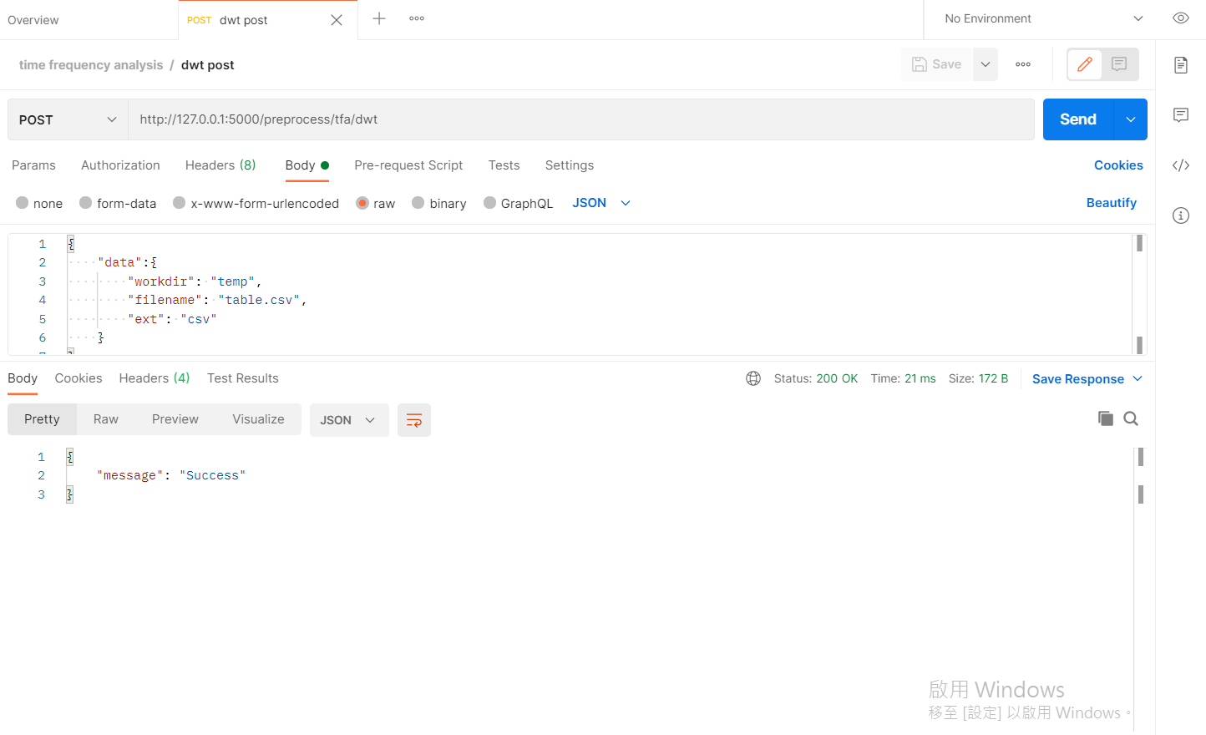

1. DWT GET:

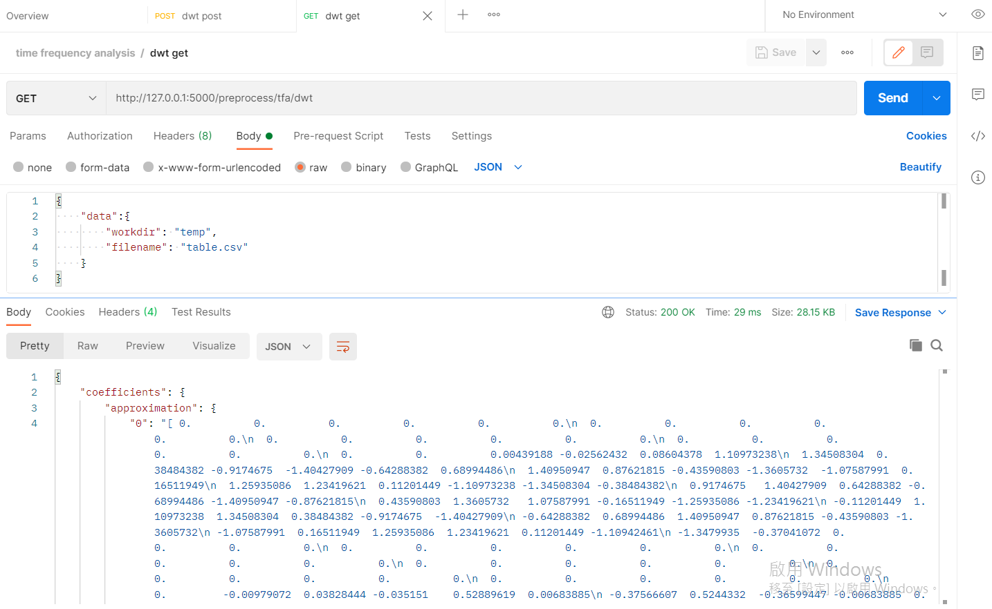

1. DWT DELETE”

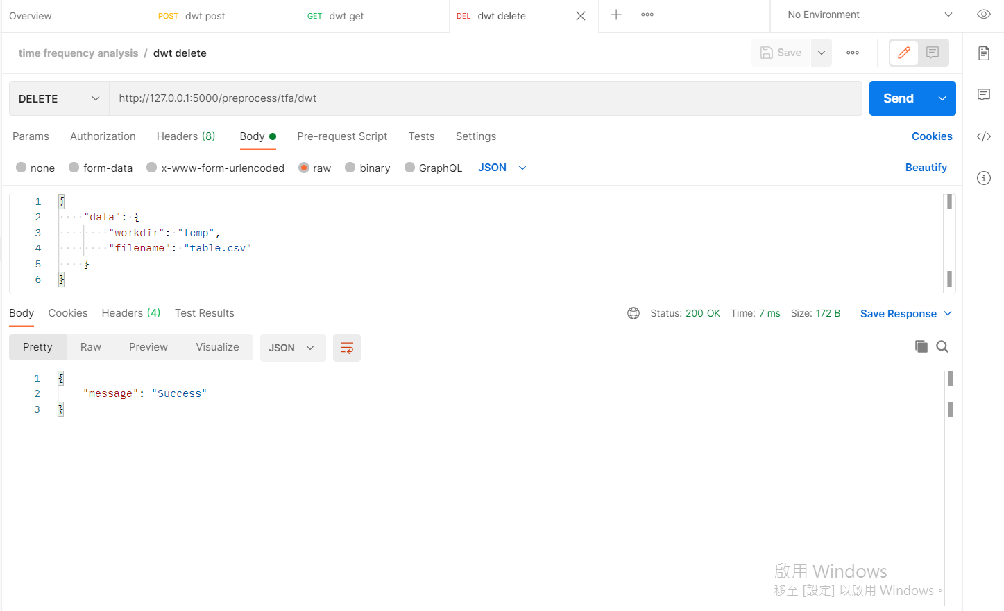

* CWT 測試:

1. CWT POST

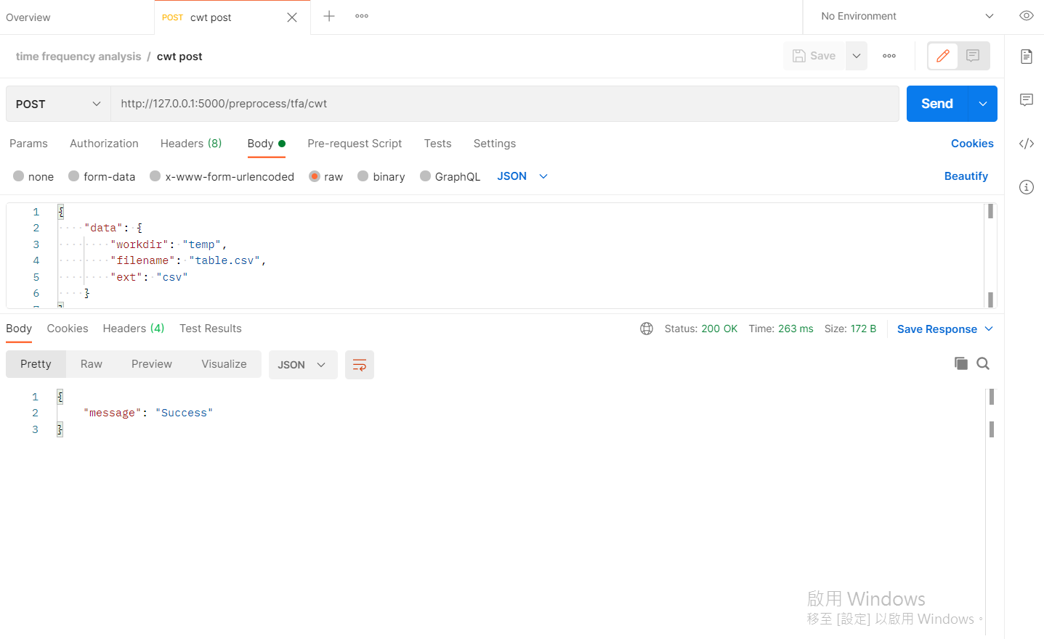

1. CWT GET:

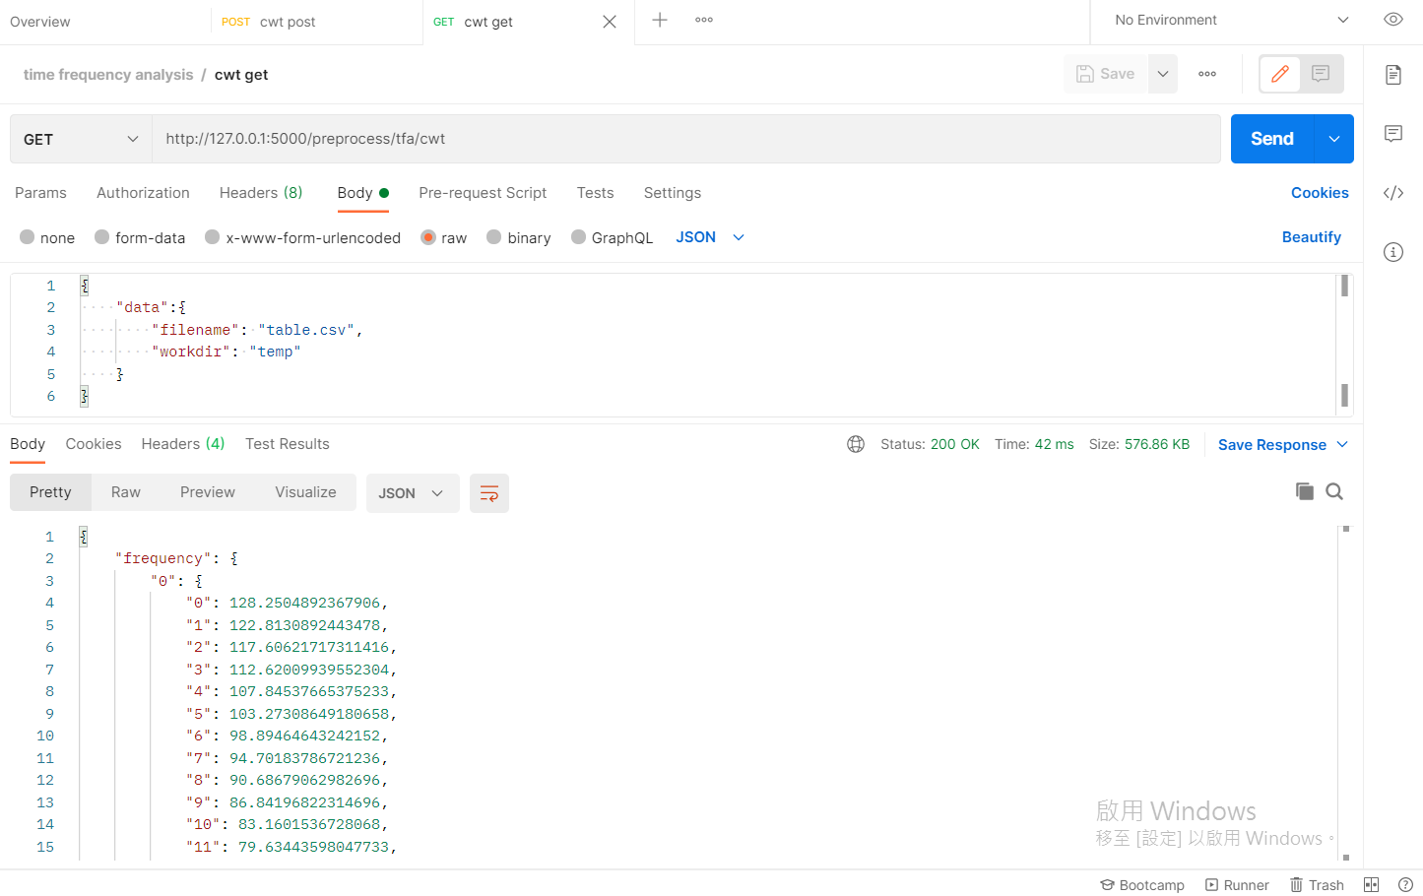

1. CWT DELETE:

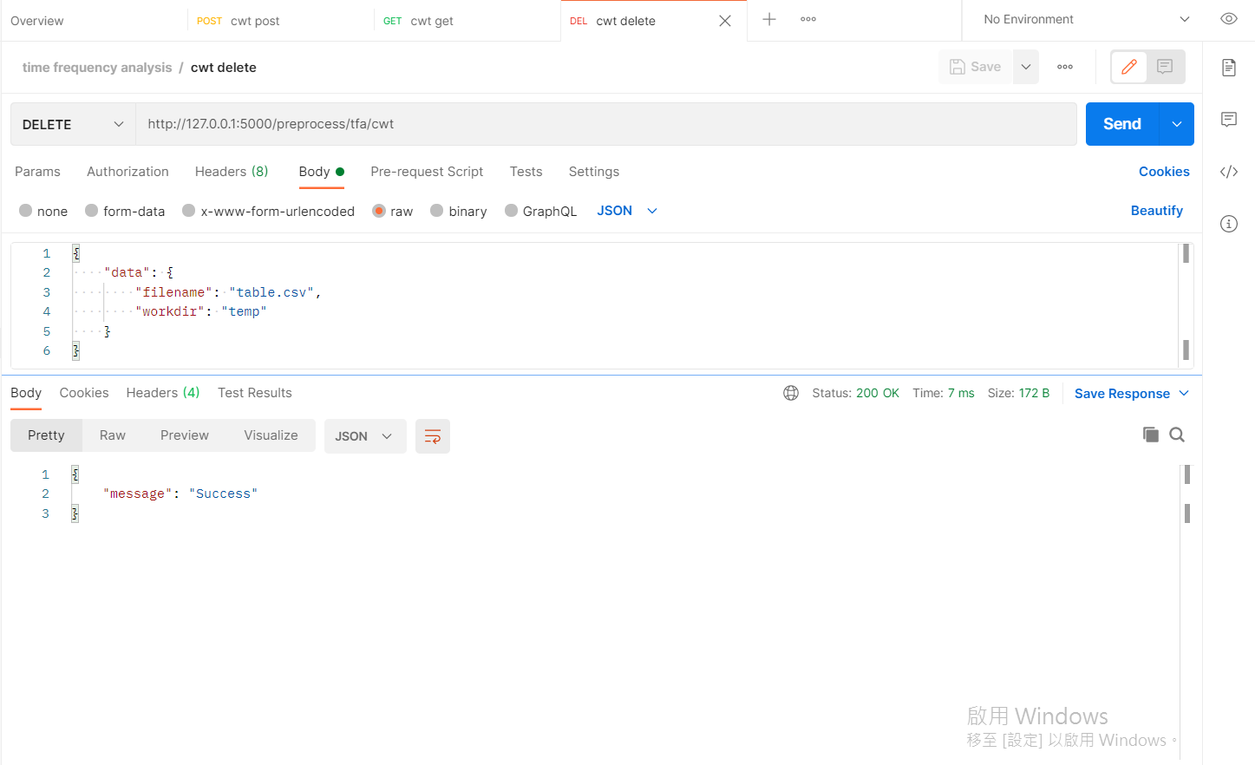

* EEMD 測試:

1. EEMD POST:

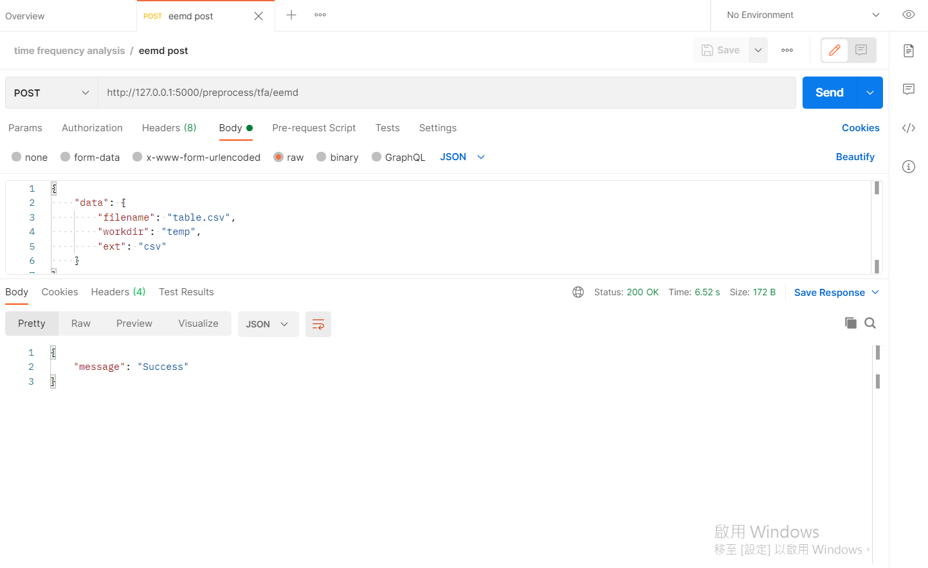

1. EEMD GET:

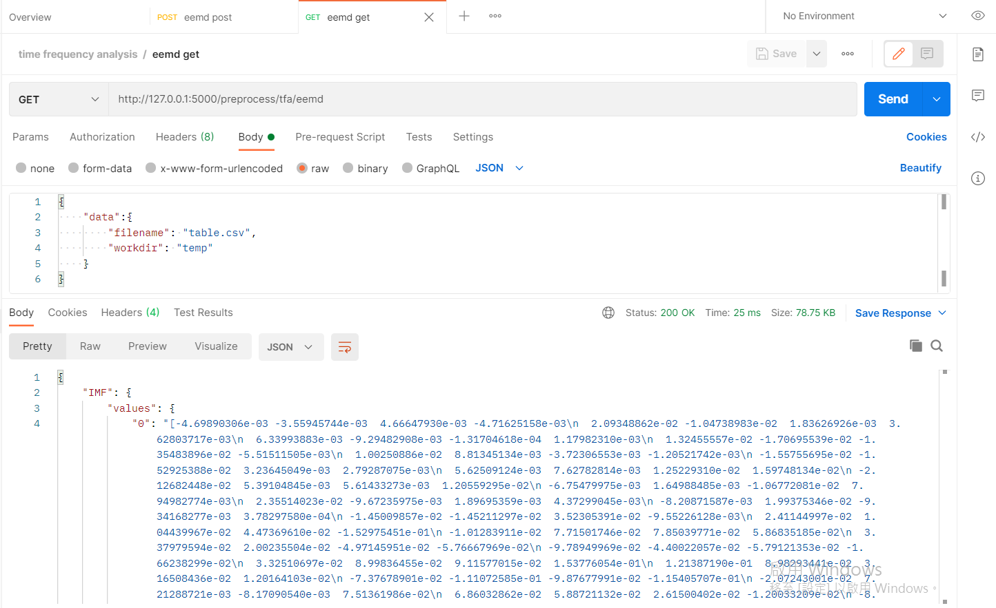

1. EEMD DELETE:

